Quality Control Robot - Mechanics

April 14, 2021

Daniel Nadeem, ECE, UBC, Vancouver, BC, Canada

**Abstract**

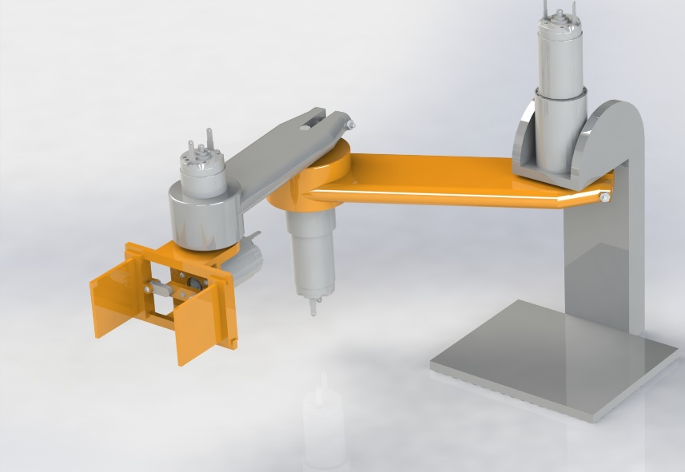The physical model of a series robot arm with an attached gripping mechanism is designed and developed to perform quality control on marshmallows. The model is then used to find a linear approximation for an operating point that is used to run a simulation of the quality control procedure.

Figure : Quality Control Robot

The physical model development and analysis is as follows; Section 1 describes the 3D design of the robot including manufacturability. Section 2 describes the method in which the linear model was approximated. Section 3 goes through the stress analysis for determining possible failing points of the robot. Section 4 describes the SimulationX model including methods used to optimize simulation time.

1. **3D Design**

The physical model consists of two arm segments, a wrist joint, and a linear gripping mechanism, providing 3.5 degrees of freedom. The first and second arm segments are 130mm and 90mm in length, respectively. The gripper claws are square with side lengths of 30mm to match the approximate size of each marshmallow.

All off-the-shelf components come from either the Faulhaber or McMaster-Carr catalogues. These components include four motor/encoder combinations, two of which contain gearheads. As well, fasteners including nuts and bolts are used to secure the robot’s parts together. The custom parts can be 3D printed from ABS plastic. These parts include the first and second arm segment, the gripper base, the two claws, and the gripping linkages.

The robot’s mounting post is designed to route wires up from the base plate, to each of the four motors along the length of the arm. The base plate serves as a housing for the electronics since the space directly above it does not conflict with the path of the robot.

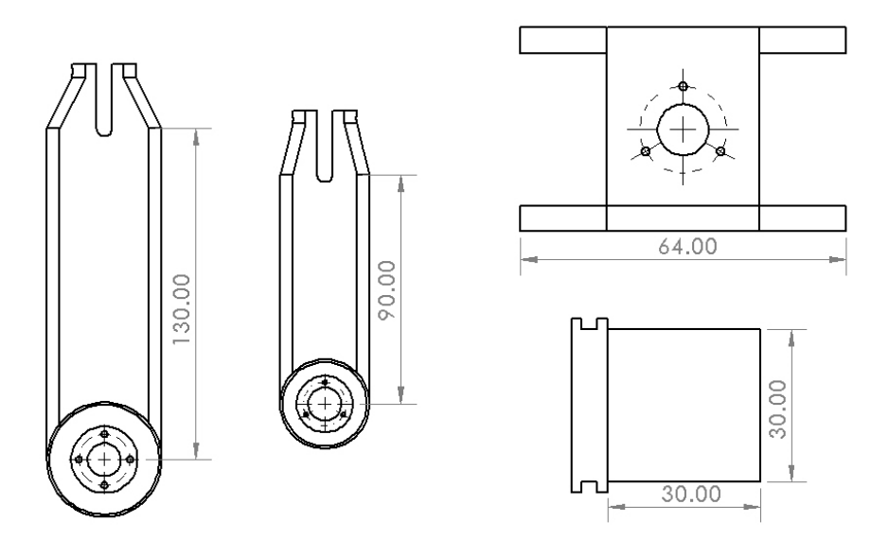

Figure : Custom ABS Parts

1. **Linear Model**

The linear model of the robot is determined using the *Mass Properties* tool in SolidWorks. The moment of inertia for each of the three arm motors is found by removing the preceding components, placing the axis of rotation at the origin, and then analyzing the mass properties. For example, the linear model for the second arm motor was found as follows:

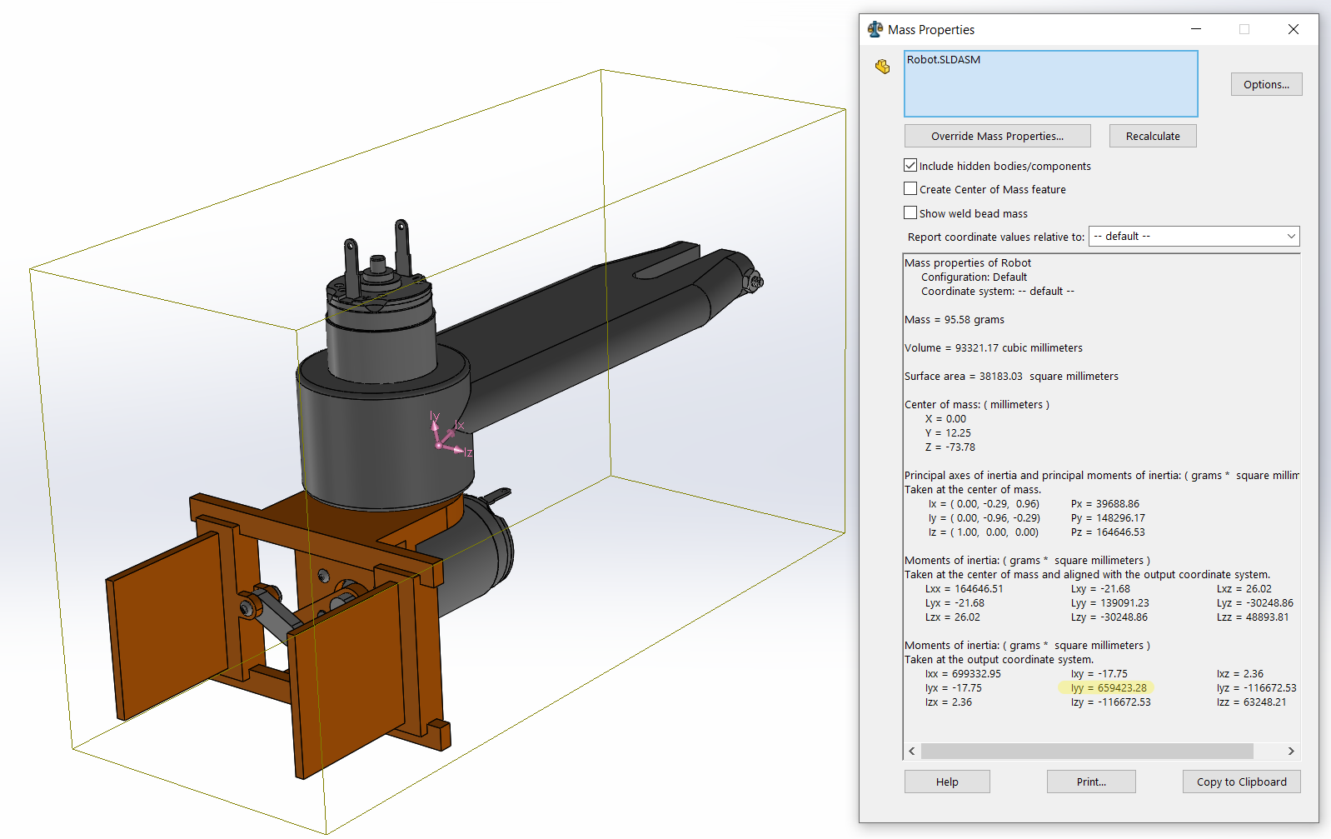

Figure : Mass Analysis

The moment of inertia experienced by the second motor is $0.659 g∙m^{2}$ which is the inertia about the y-axis; the axis of rotation of the second motor. The value for rotational friction is taken from the datasheet of the motor.

1. **Stress Analysis**

To prevent any failure of the robot’s components, the likely points of stress undergo a simulated test. Of the two arm segments, the maximum potential torque of the motor/gearhead combinations will occur from the second motor as it has the least inertia to move. Of the gripping mechanism parts, the maximum potential force will occur against the claws.

Depicted below are stress tests of the above-mentioned components. In both cases of maximum stress, neither part reaches the breaking point of ABS plastic.

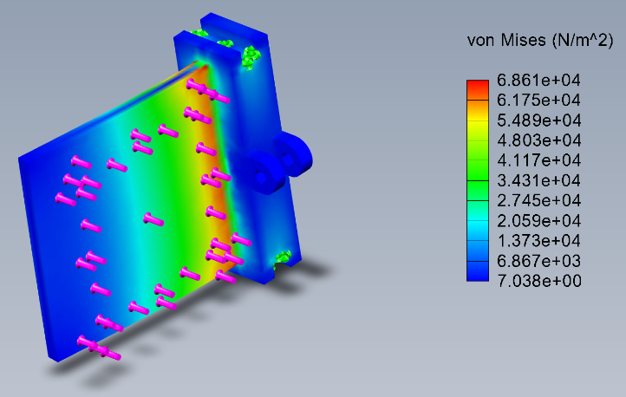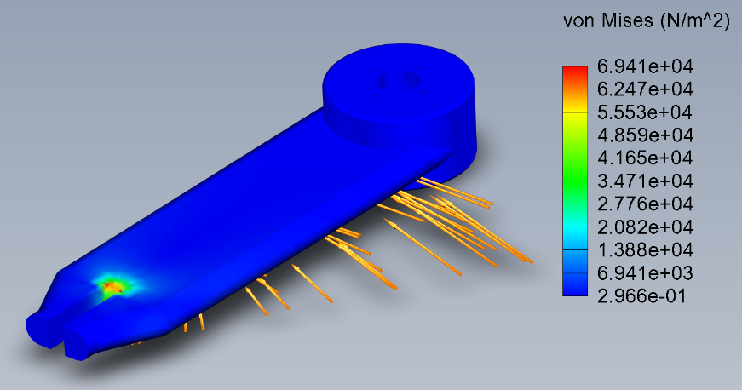

Figure : Claw Stress Analysis

Figure : Arm Segment Stress Analysis

1. **SimulationX Model**

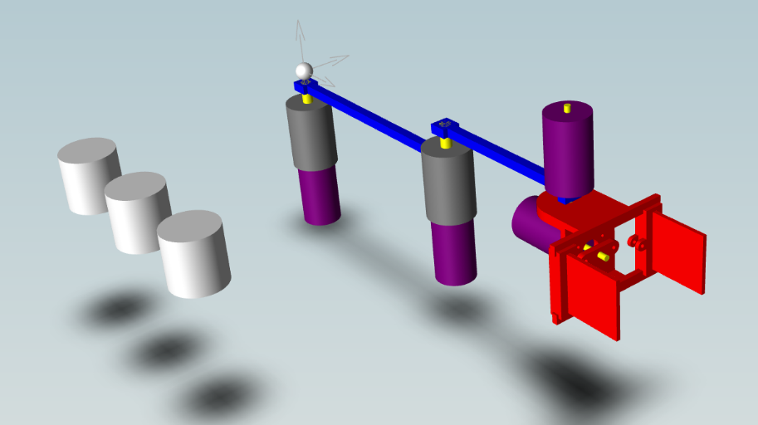The linear model that was determined earlier is not accurate enough to serve as a final simulation model, whereas a SimulationX model is. The simulation time of the model is optimized by limiting most of the components to primitive shapes and omitting certain functions of the gripping mechanism.

All of the motors are combinations of cylinders and joint blocks. As well, rather than implementing gears within the simulation, the gain of the gearheads is represented in the Simulink control model. The arm segments are represented by rectangular prisms of the same length and mass as the 3D model’s segments.

In order to greatly limit simulation time, the gripping mechanism is reduced to a single rotating component that is directly attached to the motor’s shaft. The claws are held in a fixed position. Since the gripping mechanism requires no feedback control, but a more primitive on/off control, this omission does not affect the accuracy of the control model.